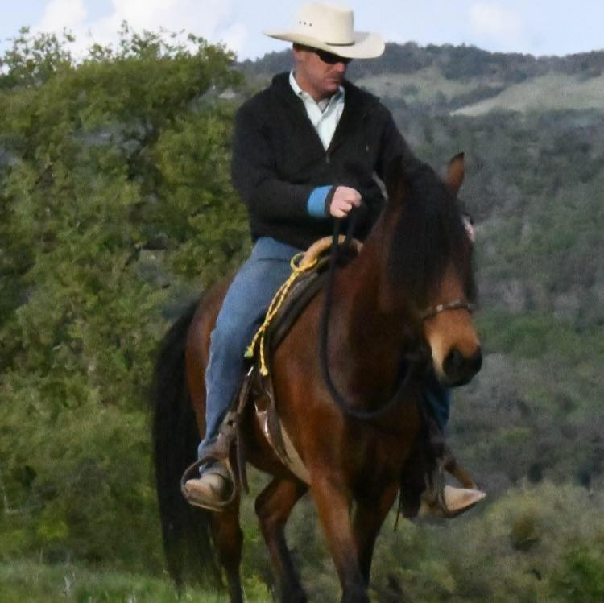  Cary Hardiman Horsemanship Clinic  - Achieve Harmony with your horse  Experience Cary’s unique style of horsemanship that is a blend of vaquero, classical, and traditional Paso Fino training.  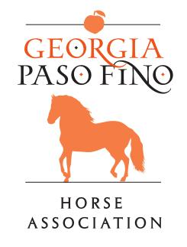  Whether your goals lead you to the trail or the show ring, Cary can help you address common problems and improve balance, collection, and straightness in harmony with your horse! | Clinic is limited to 10 riders!  Unlimited Auditors  All breeds welcome!  Achieve Harmony in Gait  Achieve Harmony on the Trail and with Obstacles  Forms and details: www.GeorgiaPasoFino.org  October 26-27, 2019  Brandreth Farm  Talking Rock, GA  (Rider check in Friday, Oct. 25th after 1:00 PM)  Contact: Lu Ann Lackey  llackey@ellijay.com

